# ASSIGNMENT ON INDEXES AND VIEWS

1. Observe that after creation of the above table you can find clustered index on primary key. Write the name of the index from object explorer

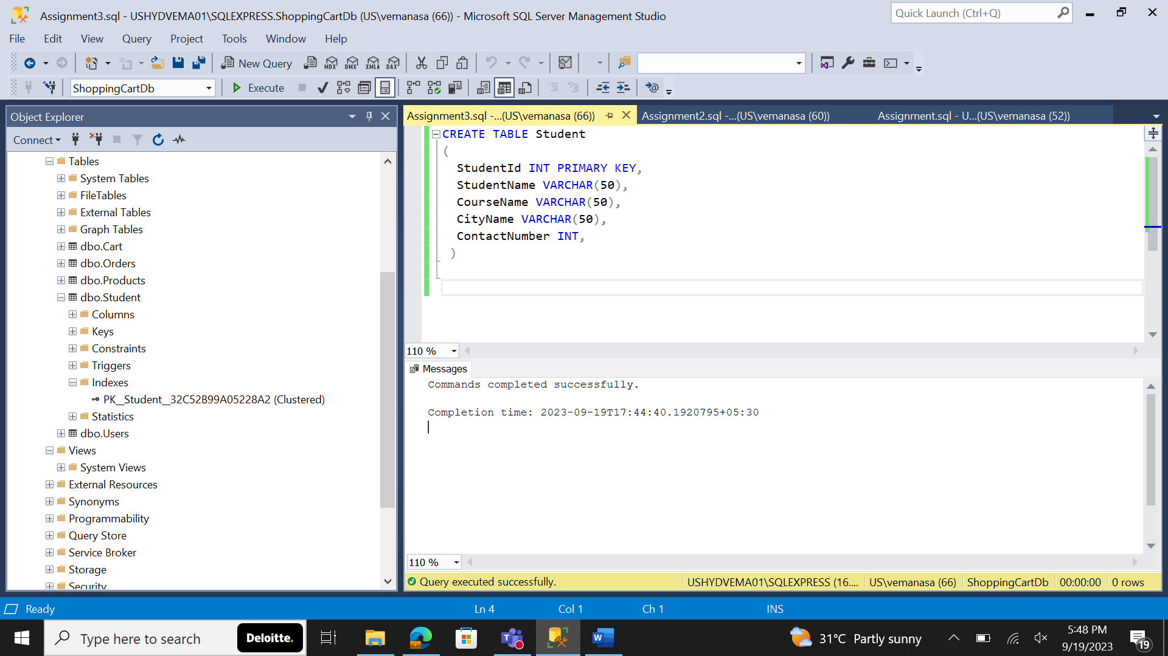

The name of the clustered index is [PK__Student__32C52B99A05228A2]

2. Create a non-clustered index on Contact Number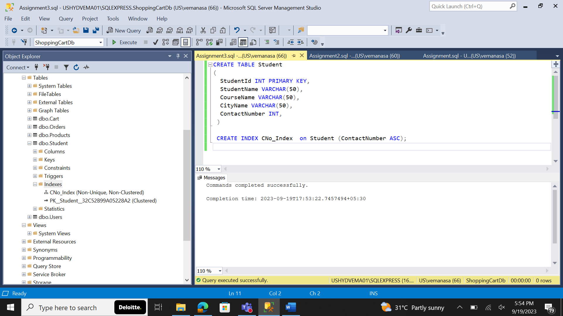

3.Create a composite index on StudentName, CourseName

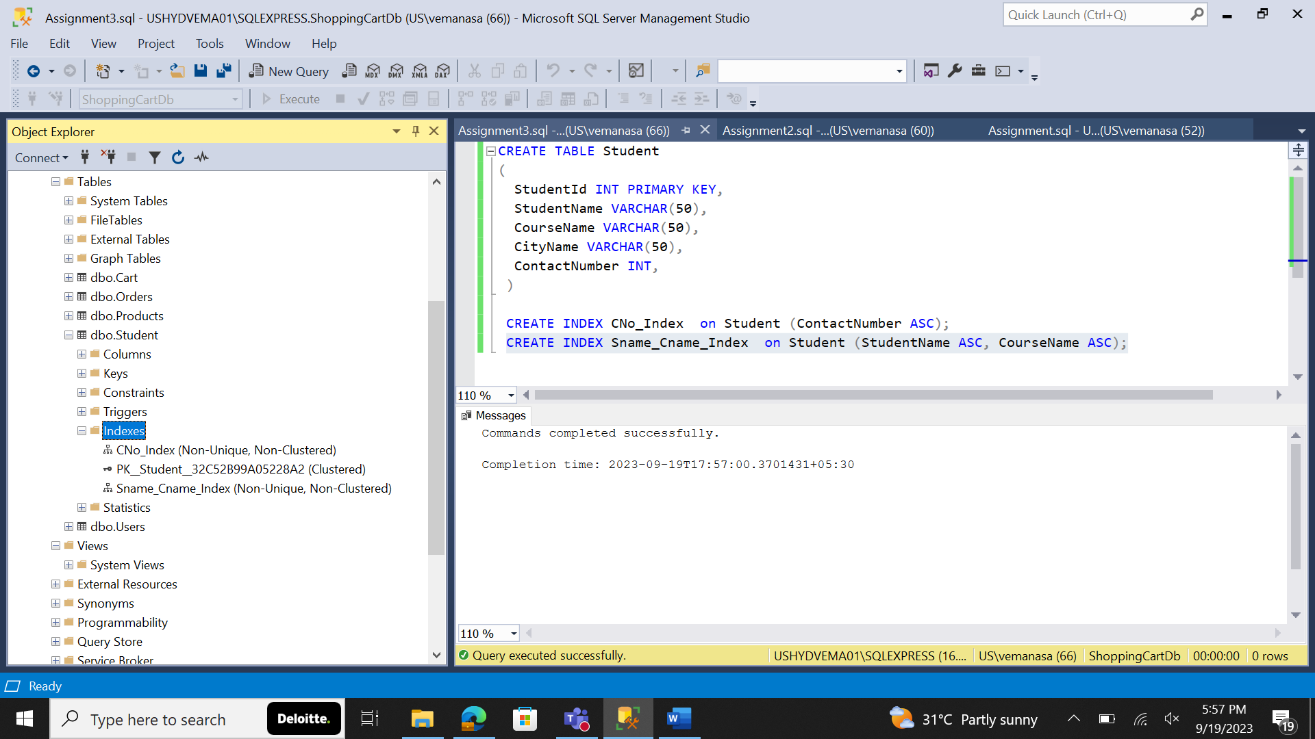

4. Finally check the following commands:

a. Drop index

b. Rename the index

c. Enable and Disable the index

a.

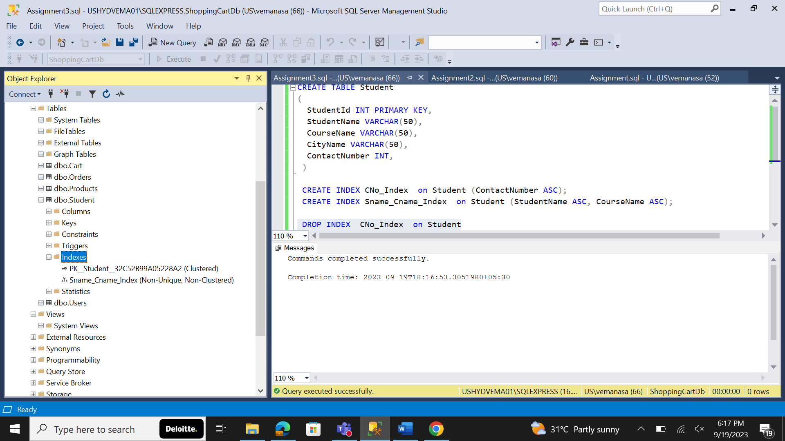

b.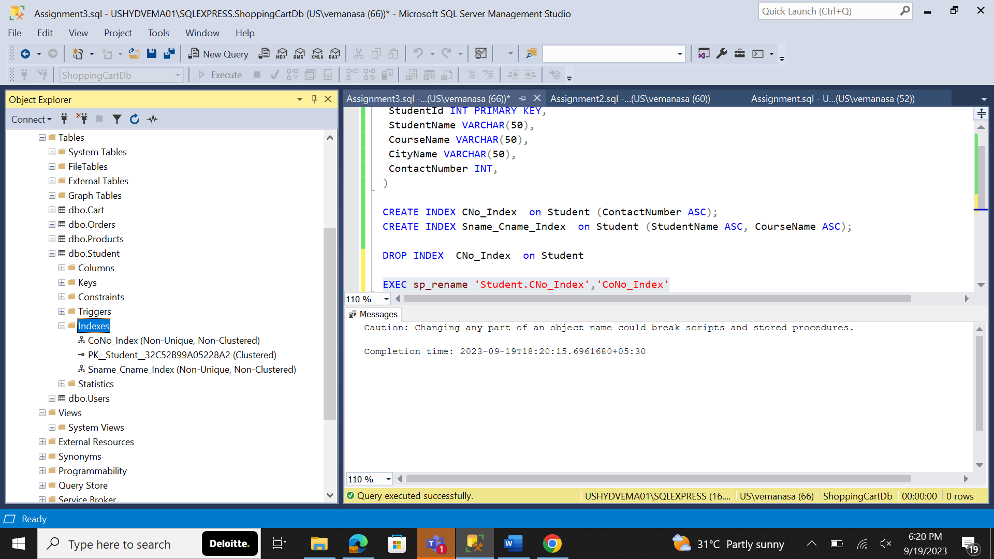

c.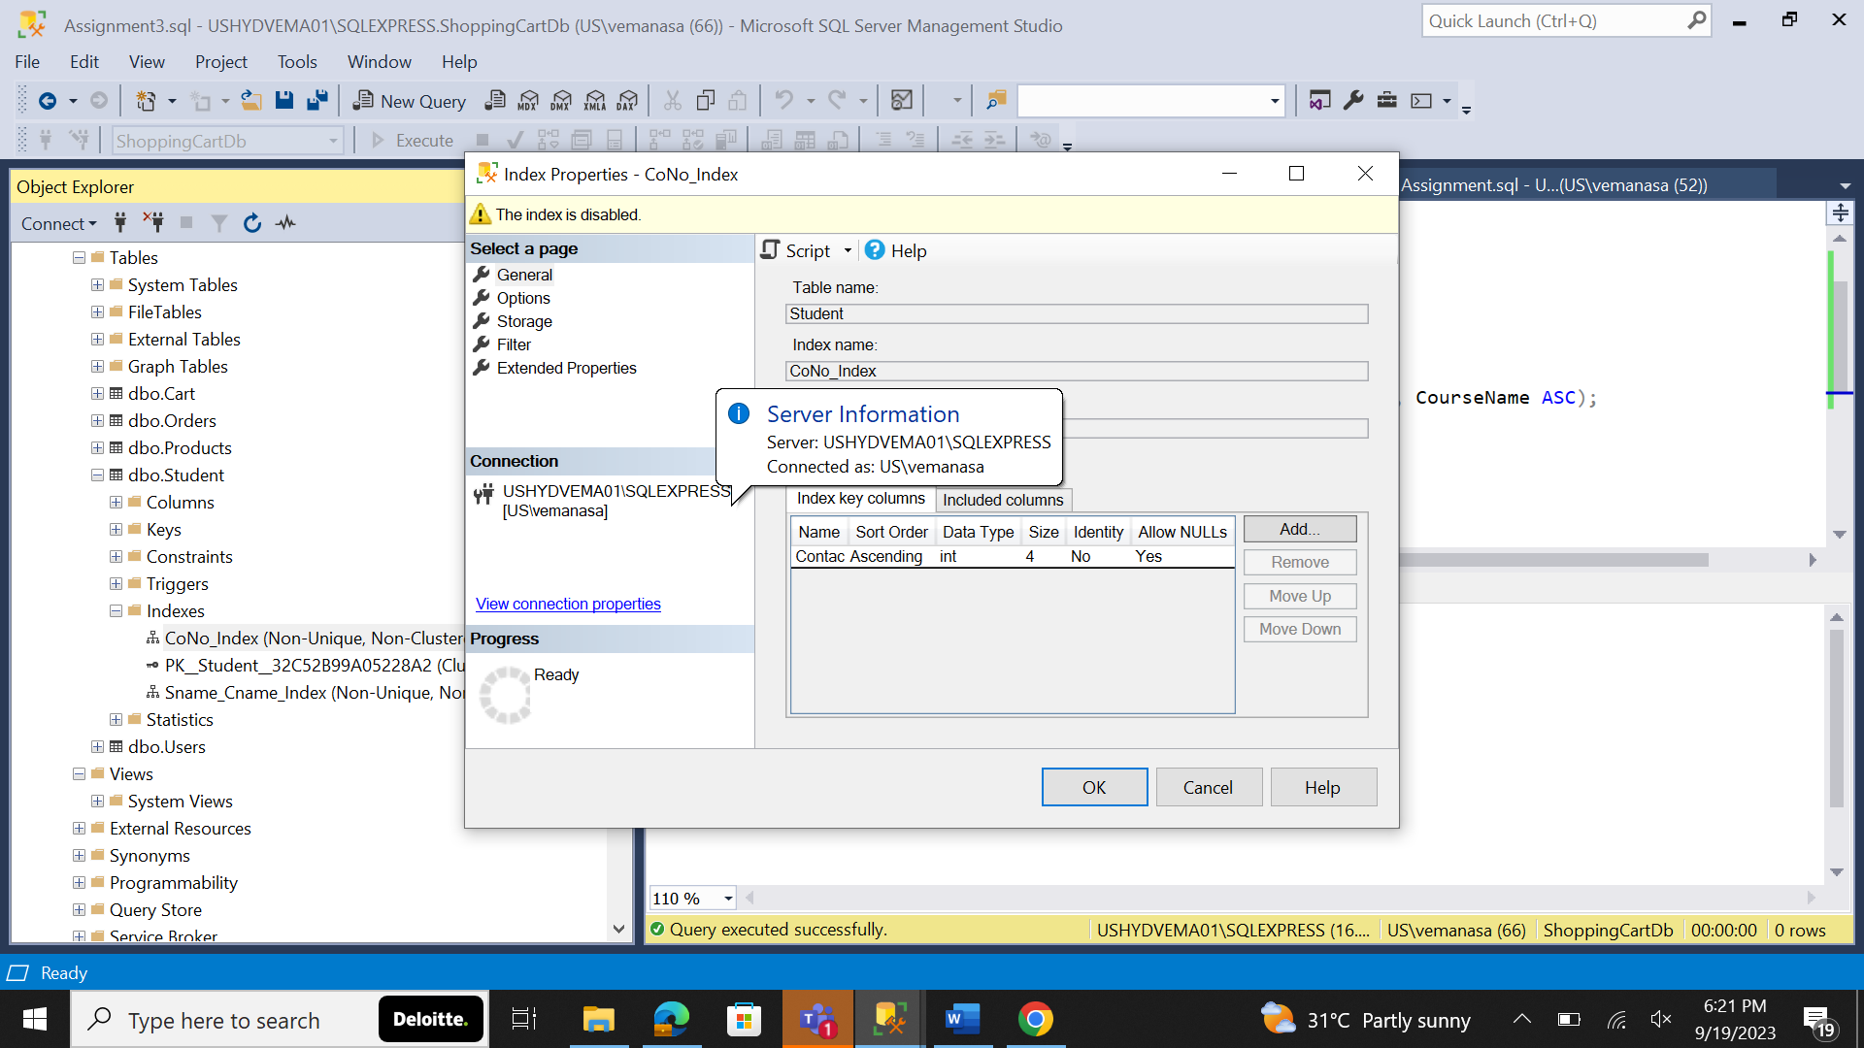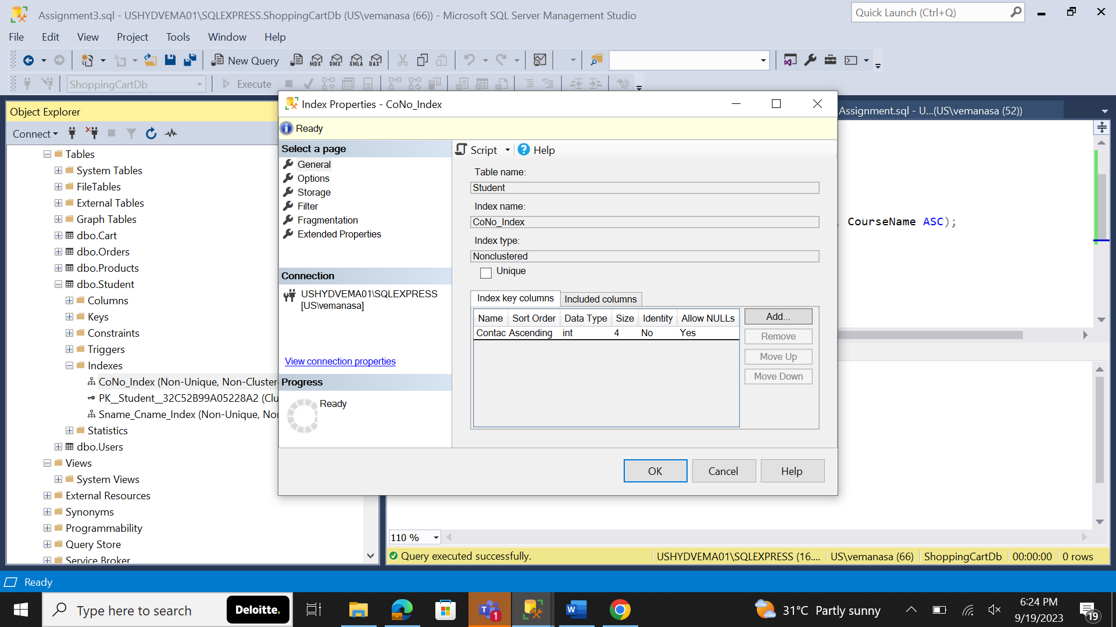

5. Check all the index 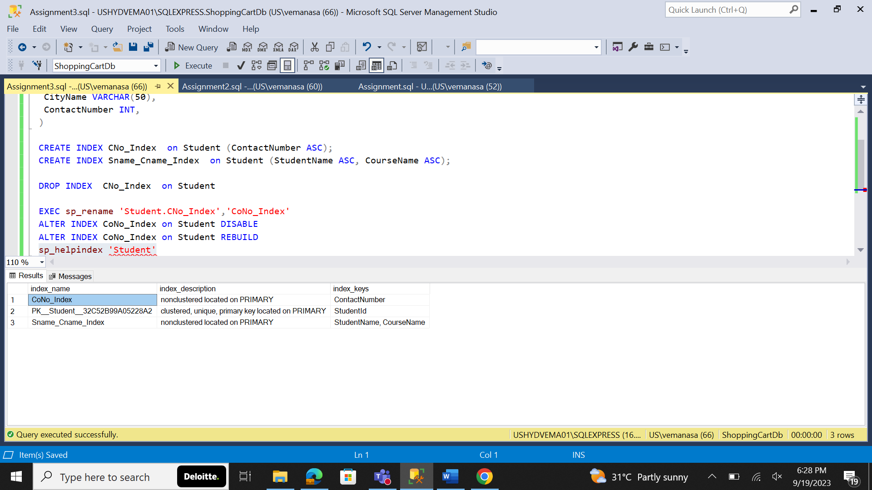

6. Implement the following requirements: a. Creates a view that selects every product in the "Products" table with a price less than the average price.

Hint : View name should be "Products Less Than Average Price"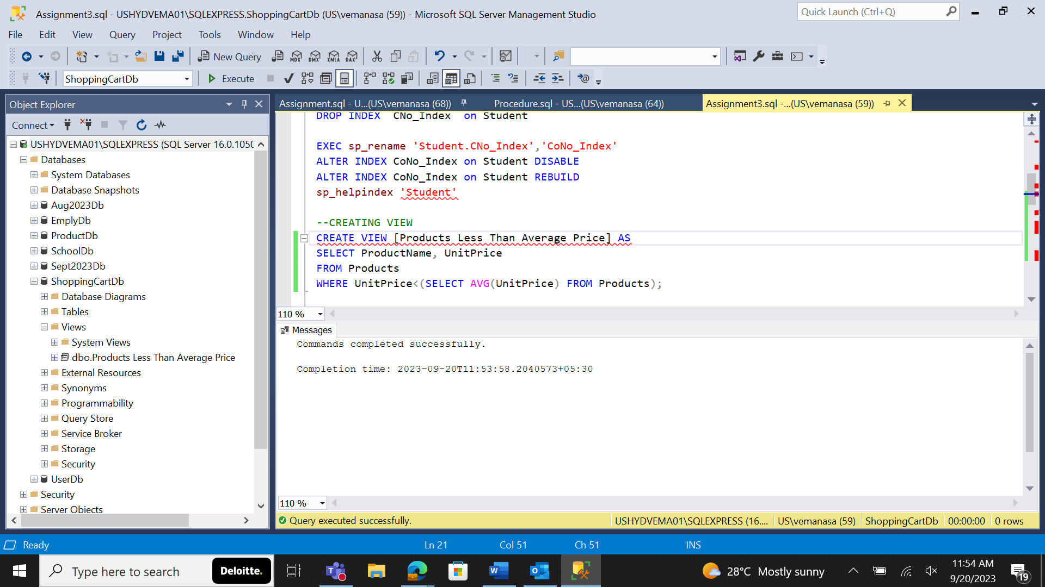

1. Display the results by using the View

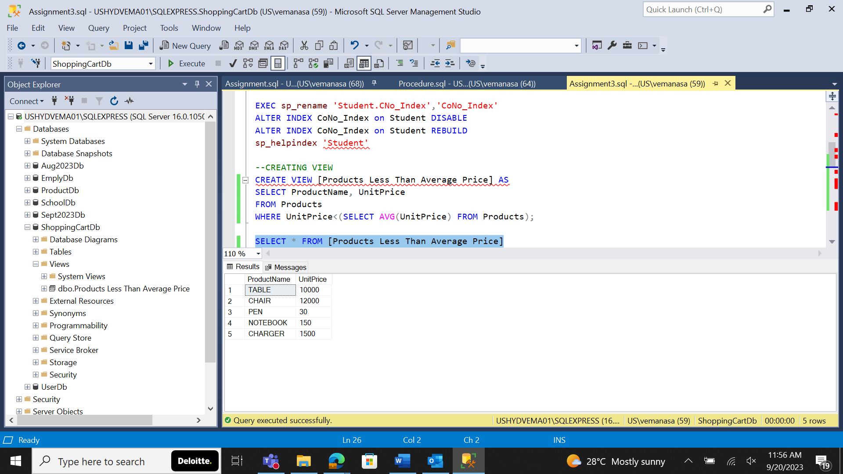

c. Rename the View as "Low Cost Products"

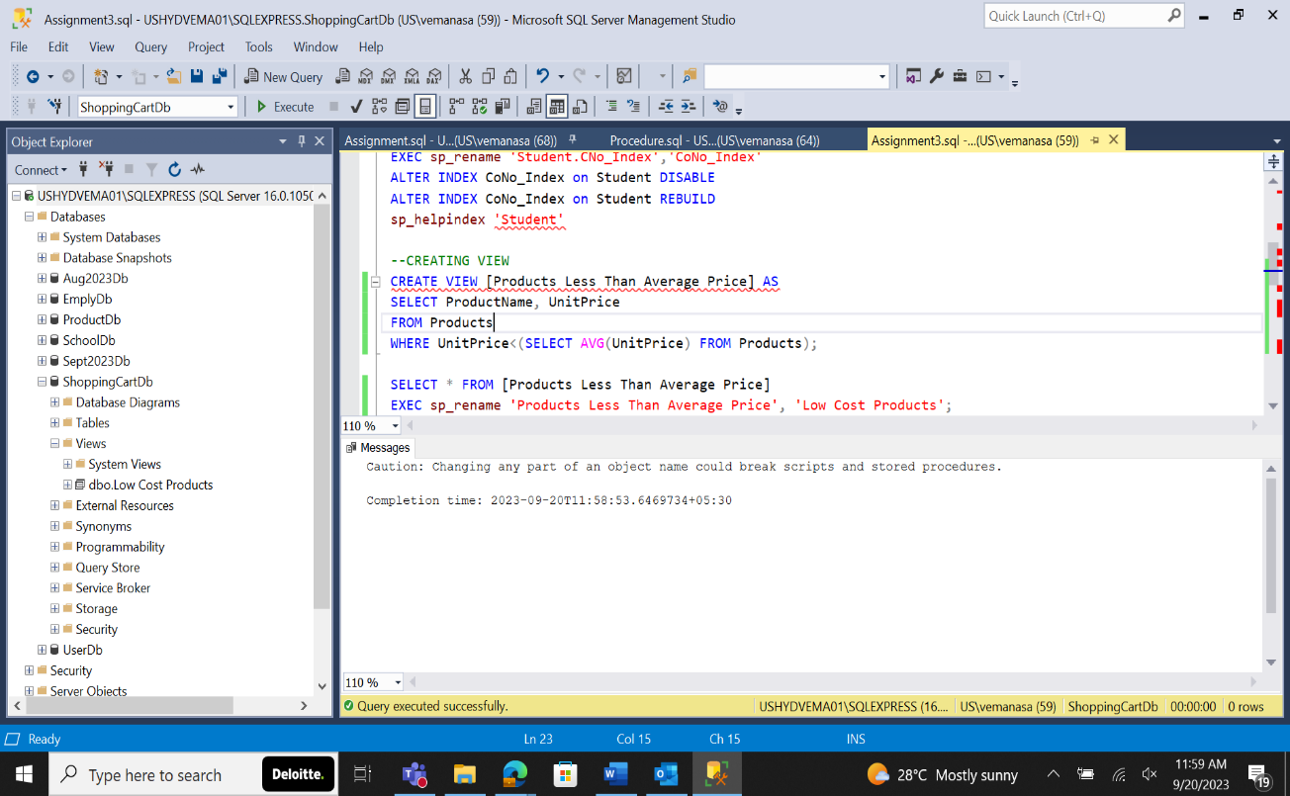

d. Drop the view